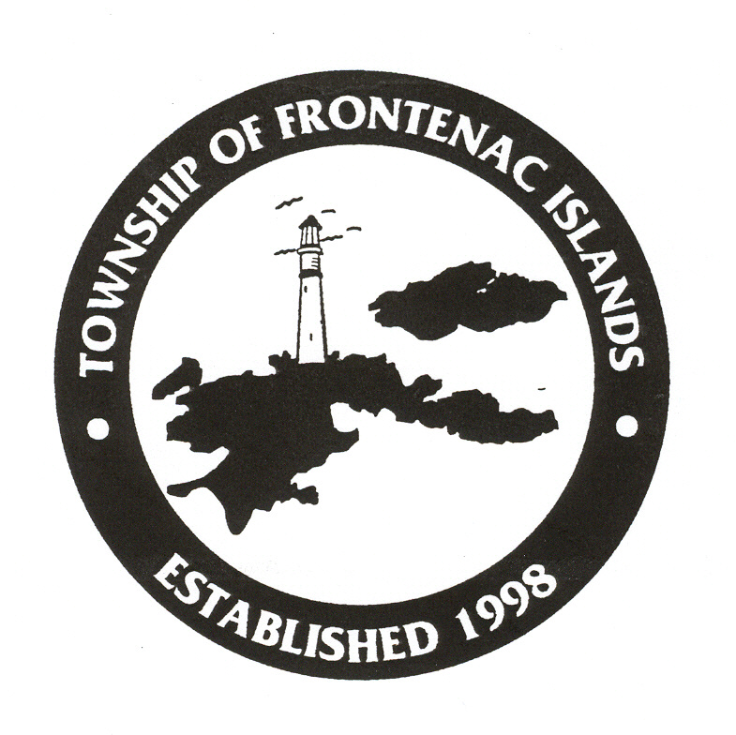
Summer Employment Opportunities

Environmental Stewards

The Township of Frontenac Islands manages a 404-hectare coastal wetland area on Big Sandy Bay (Wolfe Island) that is recognised by the Province as an Area of Natural and Scientific Interest (ANSI). The management area supports several rare or uncommon Ontario plant species, provincially and regionally significant birds and several provincially rare trees. We are currently recruiting Students for the summer of 2023.

Qualifications:
- Mature personality, dependable, and excellent interpersonal skills
- Ability to react in a proactive manner in confrontational circumstances
- Ability to work independently and responsibly with minimal supervision in a remote setting but also work well in a small team.
- Be available to work weekends, holidays, possible long and odd hours as necessary.
- Must enjoy working outdoors.
- Ability to perform multiple tasks requiring physical exertion including walking long distances in soft sand and long trails
- Valid Driver’s License
- Own Transportation
- Certification in Basic First Aid and CPR preferred.
Stewardship duties:
- Interact with the public in an open-minded, patient, and constructive manner
- Provide visitors with information about the sensitive nature.
- Collect accurate visitor traffic data.
- Collect admission fees
- Support volunteer efforts.
- Maintain the lawn, gardens, and daily chores.
- Share gate keeping duties with other environmental employees.
- Maintain the site signs and barriers and perform regular, daily area clean up.
- Other duties as assigned.

NOTE: As these positions are partially subsidized successful applicants must be returning as a full-time post-secondary student in September.

Please submit cover letter and resume by April 25, 2023, by 4pm to:

Lisa Moore-Hughes, Administrative Assistant
P.O. Box 130, Wolfe Island, ON K0H 2Y0
Office: 613-385-2216 Email: lhughes@frontenacislands.ca

We thank all applicants for their interest. Only those selected for an interview will be contacted. Personal information is collected in accordance with the Municipal Freedom of Information and Protection of Privacy Act and will be used only for employment purposes.

