

**Township of Frontenac Islands**

**Request For Quotation**

**Tender**

**Wolfe Island Public Works Facilities Grass Cutting**

**For the Services of Grass Cutting & Trimming**

**Term of the Contract is for 2 Seasons starting**

May 1st, 2024 until October 15th, 2024 - Season 1

and

May 1st, 2025 until October 15th, 2025 - Season 2

**BID NO. PW-2023-04**

**Closing Date**

**10:00 am, local time, Thursday, October 12, 2023**

***Late Quotations will not be accepted.***

***The lowest price or any Quotation is not necessarily accepted.***

# SCHEDULE OF PRICING

***QUOTATION FOR GRASS CUTTING AT VARIOUS FACILITY SITES ON***

***WOLFE ISLAND***

**CLOSING DATE: 10:00 am, local time, on Thursday, October 12, 2023.**

I/We the undersigned hereby agree to provide the services at the pricing listed below:

The proponent shall supply all equipment, supplies, and manpower to carry out the work.

**Mowing shall only be carried out on a weekly basis as needed. No mowing will take place during dry conditions.**

Mowing and trimming including hand trimming shall be carried out weekly at each site. The Municipality understands that there may be times due to extreme temperatures or lack of rain that the sites may not require mowing. The Contractor agrees that the Township will not be billed for work not completed.

The successful Proponent will be required to provide an itemized bill for each part showing the dates of each site cut and amounts on a monthly basis. Billing shall be broken down and billed separately for each Part.

**Part A – Wolfe Island Roads Department**

Prices below shall be bid per weekly cut.

|  |  |  |
| --- | --- | --- |
| A | Site A1. Public Works Garage No. 1 at 1516 Rd. 96 | $ |
| B | 13% H.S.T | $ |
| C | Total per cut | $ |

|  |  |  |
| --- | --- | --- |
| A | Site A2. Public Works Garage No. 2 at 1468 Rd. 96 | $ |
| B | 13% H.S.T | $ |
| C | Total per cut | $ |

|  |  |  |
| --- | --- | --- |
| A | Site A3. 7th Line Corner  (Frontenac Islands Rd. 96 and 7th Line Road South) both sides | $ |
| B | 13% H.S.T | $ |
| C | Total per cut | $ |

|  |  |  |
| --- | --- | --- |
| A | Site A4. Village Hill at Rd. 96 & Rd. 95 on the North/West side | $ |
| B | 13% H.S.T | $ |
| C | Total per cut | $ |

|  |  |  |
| --- | --- | --- |
| A | Site A5. Whites Picnic Area Rd. 96 Between Whites Lane and 5th Line on Rd.96 on the water side | $ |
| B | 13% H.S.T | $ |
| C | Total per cut | $ |

|  |  |  |
| --- | --- | --- |
| A | Site A6. Pykes Corner Pic Area. Rd. 95 & Stevenson Lane | $ |
| B | 13% H.S.T | $ |
| C | Total per cut | $ |

|  |  |  |
| --- | --- | --- |
| A | Site A7. at Frontenac Cty. Sign Rd. 95 north of Stevenson Ln. | $ |
| B | 13% H.S.T | $ |
| C | Total per cut | $ |

|  |  |  |
| --- | --- | --- |
| A | Site A8. Division Street West Side Behind Cemetery  Across from Community Park | $ |
| B | 13% H.S.T | $ |
| C | Total per cut | $ |

|  |  |  |
| --- | --- | --- |
| A | Site A9. McDonalds Park Picnic Area 19 Rd. 7051 | $ |
| B | 13% H.S.T | $ |
| C | Total per cut | $ |

**Part B – Wolfe Island Waste Transfer Station & Recycling Centre**

Prices below shall be bid per weekly cut.

|  |  |  |
| --- | --- | --- |
| A | Site B1. Transfer Station & Recycling Centre at 1432 Rd. 96 | $ |
| B | 13% H.S.T | $ |
| C | Total per cut | $ |

**Part C – Wolfe Island Emergency Helipad**

Prices below shall be bid per weekly cut.

|  |  |  |
| --- | --- | --- |
| A | Site D1. Wolfe Island Emergency Helipad located at 1516 Rd. 96 (Behind White Shed) | $ |
| B | 13% H.S.T | $ |
| C | Total per cut | $ |

**Part D – Wolfe Island Library**

Prices below shall be bid per weekly cut.

|  |  |  |
| --- | --- | --- |
| A | Site D1. Wolfe Island Library Branch at 10 Rd. 95 | $ |
| B | 13% H.S.T | $ |
| C | Total per cut | $ |

**Part E – Wolfe Island Medical Clinic**

Prices below shall be bid per weekly cut.

|  |  |  |
| --- | --- | --- |
| A | Site E1. Wolfe Island Medical Clinic at 102 Rd. 95 | $ |
| B | 13% H.S.T | $ |
| C | Total per cut | $ |

**Part F – Old House Museum – This site is not on the map**

Prices below shall be bid per weekly cut.

|  |  |  |
| --- | --- | --- |
| A | Site F1. Wolfe Island Old House Museum on Leander Street North. Site is across Leander St. on the opposite side of Wolfe Islands Grill.  Total area is 1820 square feet | $ |
| B | 13% H.S.T | $ |
| C | Total per cut | $ |

Company Name

_____________________________________________________________________

Address *(Please include postal code)*

_______________________________________________

Name & Position (Please print clearly.)

_______________________________________________

Signature

____________________ ________________________ _________________________

Phone No. Fax No. Email:

## Information and General Specification

Sealed quotations will be received by email at [vlatimer@frontenacislands.ca](mailto:vlatimer@frontenacislands.ca) electronically in PDF format by the Townships Clerk until **10:00 am*, local time, on Thursday, October 12, 2023***. Quotations shall be printed out and placed in a sealed envelope by the Clerk. Emails shall include the following in the Subject line “Bid No. PW-2022-01, Wolfe Island Public Works/Facilities Grass Cutting. Bidders shall request a read receipt to ensure delivery and acceptance of the Bid. The Township Clerk and CAO are the only Staff with access to the procurements email.

All addenda issued by the Township should be acknowledged on the Form of Tender above.

**Quotations will be opened on Thursday, October 12, 2023, at 1 pm at the Howe Island Municipal Office. Bidders are welcome to attend the bid opening.**

Quotation envelope shall include the duly executed “Schedule of Unit Prices” and any addenda issued by the Township should be acknowledged below the Schedule of Unit Prices.

Quotations must be submitted on all quotation forms supplied and be properly signed.

The quotation must be legible, and all items must be bid. Quotations that are incomplete, unbalanced, conditional, or obscure, or which contain erasures or alterations not properly initialed, or irregularities of any kind may be rejected as informal or void.

The bid must not be restricted by a statement added to the quotation form or by a covering letter or by alterations to the quotation form provided. Adjustments to a quotation already submitted will not be considered. A proponent desiring to make adjustments to a quotation must withdraw the quotation and/or supersede it with a later quotation submission.

Written requests for withdrawal of quotations received prior to closing time will be allowed.

Should the quotation be submitted past the time and date stated in the document, the envelope will be time and date stamped and returned unopened to the proponent.

This quotation involves the supply of service and appropriate equipment to carry out Lawn Care Maintenance (Grass cutting) within various set-out areas on Wolfe Island.

The term of this contract shall be for 2 Seasons commencing May 1st, 2024, until October 15th, 2024, and re-commencing May 1st, 2025, and ending on October 15th, 2025.

**Site Map attached on Page 17.**

**Lowest, or any, quotation not necessarily accepted.**

**Bidder Expense**

Any expenses incurred by the Proponent in the preparation of the quotation submission are entirely the responsibility of the Proponent and will not be charged to the Corporation.

**Terms of Payment**

Unless otherwise stated herein, the Corporation’s normal terms of payment will be Net Sixty (60) calendar days from the receipt of Goods/Services or the Date of Invoice, whichever occurs later. Invoices shall be forwarded for each part and sent via email to: [invoices@frontenacislands.ca](mailto:invoices@frontenacislands.ca) stating the following mailing address on the invoices.

The Corporation of the Township of Frontenac Islands, 1191 Rd. 96, P.O. Box 130, Wolfe Island, ON, K0H-2Y0

## Contract Award

The successful proponent will be notified after the November 14, 2023, Council meeting. It is the intent of the Township to award this quotation to the most responsive and responsible proponent, based upon the submissions received. The Township's decision as to the award will be final.

## Right to Accept or Reject Quotation

**THE CORPORATION OF THE TOWNSHIP OF FRONTENAC ISLANDS RESERVES THE RIGHT TO REJECT ANY OR ALL QUOTATIONS.**

## Clarification

It shall be the Proponent’s responsibility to clarify any points in question with the undersigned prior to submitting the quotation.

Proponents finding discrepancies or omissions or having doubt as to the meaning or intent thereof, shall at once notify the undersigned who shall, if necessary, send written instruction or explanations to all bidders.

Questions arising during the bidding period should be directed to:

**Troy Gilmour – CAO – 613.385.2216**.

Alternatively, queries may be forwarded via email to: tgilmour@frontenacislands.ca

**Addenda**

All addenda issued by the Township should be acknowledged on the quotation below the schedule of unit prices.

## Statutes & Regulation

The Contractor shall comply with all Federal, Provincial, and Municipal laws and regulations including but not limited to the Workplace Safety and Insurance Act, Ontario Provincial Health and Safety Act, and Regulations including W.H.M.I.S.

## Licenses and Approvals

The successful proponent shall, at their own expense, be responsible for maintaining and keeping all municipal and any other licenses, or approvals, necessary to permit them, their employees, or the company, to carry out the requirements of the agreement.

**M.S.D.S.**

The successful proponent must be able to provide applicable Material Safety Data Sheets for all materials being used to perform the work at any time.

**W.S.I.B.**

The successful proponent must at all times pay, or cause to be paid, any assessment or compensation required to be paid, pursuant to the Workplace Safety & Insurance Act. The proponent shall provide the Township with a “Certificate of Clearance” issued by the Workplace Safety & Insurance Board within 7 (seven) calendar days after notification of award and shall be responsible for providing updates as required during the duration of this contract.

## Sales Tax

The harmonized sales tax (H.S.T.) for each site shall be recorded in the price breakdown.

Price adjustments imposed by the Federal or Provincial Governments will only become effective on the date(s) stated and/or upon the expiry of all stipulated waiting period(s), whichever is the longer period.

**Site Visit**

**It is recommended that all proponents examine all areas for mowing and trimming. No extras or allowances will be made should the proponent fail to do so.**

## Insurance

Within 14 calendar days of notification of award, the successful bidder must provide the Township with a certificate of insurance in compliance with insurance requirements stipulated below. A valid copy of the certificate of insurance shall be in the Township’s possession at all times.

Commercial General Liability Insurance issued on an occurrence basis for an amount of not less than $2,000,000 per occurrence / $2,000,000 annual aggregate for any negligent acts or omissions by the bidder relating to its obligations under this Agreement. Such insurance shall include but is not limited to bodily injury and property damage including loss of use; personal injury; contractual liability; premises, property & operations; non-owned automobile; broad form property damage; owners & contractors protective; occurrence property damage; products & completed operations; employees as Additional Insured(s); contingent employers liability; tenants legal liability; cross liability and severability of interest clause.

Such insurance shall add the Corporation of the Township of Frontenac Islands as additional Insured. This insurance shall be non-contributing with and apply as primary and not as an excess of any insurance available to the Corporation. The successful bidder shall indemnify and hold the Corporation of the Township of Frontenac Islands harmless from and against any liability, loss, claims, demands, costs, and expenses, including reasonable legal fees, occasioned wholly or in part by any negligence or acts or omissions whether willful or otherwise by the bidder, its agents, officers, employees, or other persons for whom the bidder is legally responsible. The policy should not have a deductible greater than Two Thousand Dollars ($2,000).

The contractor shall also furnish the Corporation with a certified copy of a Standard Automobile Liability Insurance Policy on all owned and leased vehicles with inclusive limits of not less than Two Million Dollars ($2,000,000) per occurrence for bodily injury and property damage with a deductible not greater than Two Thousand Dollars ($2,000).

All policies:

* shall apply as primary insurance and not excess to any other insurance available to the Corporation; are to remain in force until final acceptance of the work described herein by the Corporation;
* at the expiry date of the policies, the Bidder shall provide original signed Certificates or electronic equivalents thereof, evidencing renewals or

replacements to the Corporation prior to the expiration date of the original policies without notice or request by the Corporation.

The policies shown above shall not be cancelled, permitted to lapse, or materially changed unless the Insurer notifies the Corporation in writing at least thirty (30) days prior to the effective date of the cancellation. The insurance policy will be in a form and with a company that is, in all respects, acceptable to the Corporation.

**Health and Safety Policies and Procedures**

The Frontenac Islands “Health and Safety Policy and Procedures Manual” states that all contractors and sub-contractors shall:

1. *Demonstrate the establishment and maintenance of a health and safety program,*

*objectives, and standards consistent with applicable legislation and this corporation’s*

*health and safety policy requirements.*

1. *Include health and safety provisions in their management system to reach and maintain a consistently high level of health and safety.*
2. *Ensure the workers in their employ are aware of the hazardous substances that may be in use at the workplace and wear the appropriate personal protective equipment required for the area.*
3. *All accidents/incidents and near misses are to be reported to the supervisor of the contract immediately or as soon as possible.*

It is understood that all parties involved in this contract shall comply with the above and the current Ontario Health and Safety Act and Regulations. The contractor must certify that they have an appropriate Health & Safety Policy in place and be in compliance with the requirements of the Ontario Regulation 297/13 made under the OHSA.

**Accessibility Standards for Customer Service, Disabilities Act.**

It is the Proponent’sresponsibility to ensure that they and all sub-contractors hired under this contract are in full compliance with Section 6 of Ontario Regulation 429/07, Accessibility Standards for Customer Service made under the Accessibility for Ontarians with **Disabilities Act,** 2005 as may be amended from time to time.

## Treatment of Information

The information submitted in response to this request will be treated in accordance with the relevant provisions of the Municipal Freedom of Information and Protection of Privacy Act (MFIPPA). The information collected will be used solely for the purposes stated in this request.

If the Bidder believes that any part of its bid reveals any trade secret, intellectual property, scientific, technical, commercial, financial, or labour relation information or any other similar secret right of information belonging to the Bidder, the information must be clearly marked as being confidential.

This does not apply to the lump sum pricing information that will be read out at the public opening. Unit prices as defined under the MFIPPA will not be provided at the public opening. Any requests for access to submissions will be subject to a formal review based on MFIPPA requirements prior to the release of any third-party information.

# GENERAL TERMS & CONDITIONS

## Scope

These standard quotations, contract terms, and conditions form a part of each quotation proposal and contract and apply in like force to contracts for the purchase of materials, supplies, equipment, and services. All quotations issued by the Township of Frontenac Islands will bind bidders to the terms and conditions herein set forth, except as specifically qualified in Special Quotation and Contract Terms and Conditions issued in connection with any individual quotation.

## Definitions

As used herein as well as in all specifications, quotations, awards, contracts, etc. issued by the Township of Frontenac Islands, the following definitions shall apply, unless otherwise indicated:

Township: The Corporation of the Township of Frontenac Islands

Division: Public Works Department, of the Township of Frontenac Islands

Agency: Any Township Department

Proponent/Bidder: Any Individual, Firm, Company, or Corporation submitting proposals

on quotations issued by the Township of Frontenac Islands

Quotation: The documents comprising an invitation to bid for furnishing commodities of

services

Proposal: The offer of a Bidder to furnish commodities or services in response to a

quotation.

Contract: The acceptance by the Township of a proposal by a Bidder to furnish

commodities or service

Contractor: Any Individual, Firm, Company, or Corporation to whom a contract is awarded

against a proposal submitted

Any alleged oral agreement or arrangement made by a Proponent or Contractor with

any agency or an employee of the Township of Frontenac Islands will be disregarded.

## Submission of Proposal

**Proposals must be submitted by email only, clearly indicating the contents as well as the name and address of the Proponent.**

Proponents are cautioned to verify their proposals before submission. Proposals received by the Township of Frontenac Islands, later than the time and date specified, cannot be considered.

All information required in quotation forms in connection with each item against which a proposal is submitted must be given to constitute a valid proposal. In the event of any discrepancy between the unit price and the extension, the unit price shall govern.

The proponent declares that the proposal is NOT made in connection with any other proponent submitting a proposal for the same commodity(ies) and is in all respects fair and without collusion or fraud.

## Award

The Township reserves the right to award by item, or part thereof, group of items, or parts thereof, or all items of the quotation, and to award contracts to one or more proponents submitting identical proposals as to price; to reject any and all proposals in whole or in part;

to waive technical defects, irregularities, and omissions if, in so doing, the best interests of the Township will be served.

The Township reserves the right to make awards within forty-five (45) days from the date the proposals are opened.

A proponent must be prepared, if requested, to present evidence of experience, ability, service facilities, and financial standing necessary to meet satisfactorily the requirements set forth or implied in the quotation.

## Contract

Each proposal will be received with the understanding that the acceptance in writing by the Township of the offer to furnish all or any part of the commodities described therein shall constitute a contract between the Proponent and the Township, which shall bind the Proponent on his part to furnish and deliver the commodities at the prices given and in

accordance with the conditions of said accepted proposal and specification and the standard quotation and contract terms and conditions and the Township on its part to take delivery of and pay for the services at the contract prices.

No alterations or variations of the terms of the contract shall be valid or binding upon the Township unless authorized in writing.

## Acceptance of Contract

The placing in the mail to the address given in his/her proposal or delivery of a notice of award to a bidder will constitute notice of acceptance of the contract. When so requested by the Township the Contractor shall execute a formal contract with the Township for the complete performance specified therein.

The contract may be cancelled by the Township upon non-performance of contract terms within seven (7) days from notification.

Failure of a Contractor to deliver within the time specified or within a reasonable time as interpreted by the Township or failure to make replacements or rejected services when so requested will constitute authority for the Township to purchase in the open market to replace the services rejected or not delivered. The Township reserves the right to authorize immediate purchases in the open market against rejections or any contract when necessary.

On all such purchases, the Contractor agrees to promptly reimburse the Township for excess costs occasioned by such purchases. Such purchases will be deducted from the

Contract quantities. However, should public necessity demand it, the Township reserves the right to use services that are substandard in quality, subject to an adjustment in price to be determined by the Township.

When services are rejected, same must be removed by the Contractor from the premises of the Township within five (5) days after notification unless public health and safety require immediate destruction or other disposal of such rejected delivery in which case the Township may take such action as it deems necessary. Rejected items left longer than five (5) days will be considered abandoned, and the Township shall have the right to dispose of them as its own property.

The Township reserves the right to remove from eligibility to submit proposals for an indeterminate period, the name of any Proponent for failure to accept contract, or the name of any Contractor for unsatisfactory performance of contract.

## Assignment of Contract

It is mutually agreed and understood that the Contractor shall not assign, transfer, convey, sublet, or otherwise dispose of his contract, his right, title, or interest therein, or his power to execute such contract, to any other person, firm, company, or corporation without the previous written consent of the Township.

## Contract Guarantee

The contractor hereby covenants and agrees:

1. To perform the contract in accordance with the specifications and proposal under which the contract is awarded.

1. To save the Corporation of the Township of Frontenac Islands, its agent, or employees, harmless from liability of any kind for the use of any composition, secret process, invention, article, or appliance furnished or used in the performance of the contract of which the Contractor is not the patentee, assignee, or licensee.

1. To furnish adequate protection from damage from all work and to repair damage of any kind, for which he or his workmen are responsible, to the premises or equipment, to his own work, or the work of other contractors.

1. To pay for all permits, licenses, and fees, and to give all notices and comply with all by-laws and regulations of the Township.

1. To carry such insurance as may be required by the Township, and to furnish satisfactory proof thereof when required by the Township.

# SAMPLE - QUOTATION ENVELOPE

All “QUOTATION” envelopes must be clearly identified as such so that they are not inadvertently opened by staff. Further, it is also essential that all proponents clearly identify the quotation as Mowing as well as the company submitting the bid.

***QUOTATION: BID NO. PW-2023-04***

***WOLFE ISLAND PUBLIC WORKS GRASS CUTTING & TRIMMING***

***COMPANY: __________________________________________________***

The Township of Frontenac Islands Public Works Dept***.***

Emailed to:

[vlatimer@frontenacislands.ca](mailto:vlatimer@frontenacislands.ca)

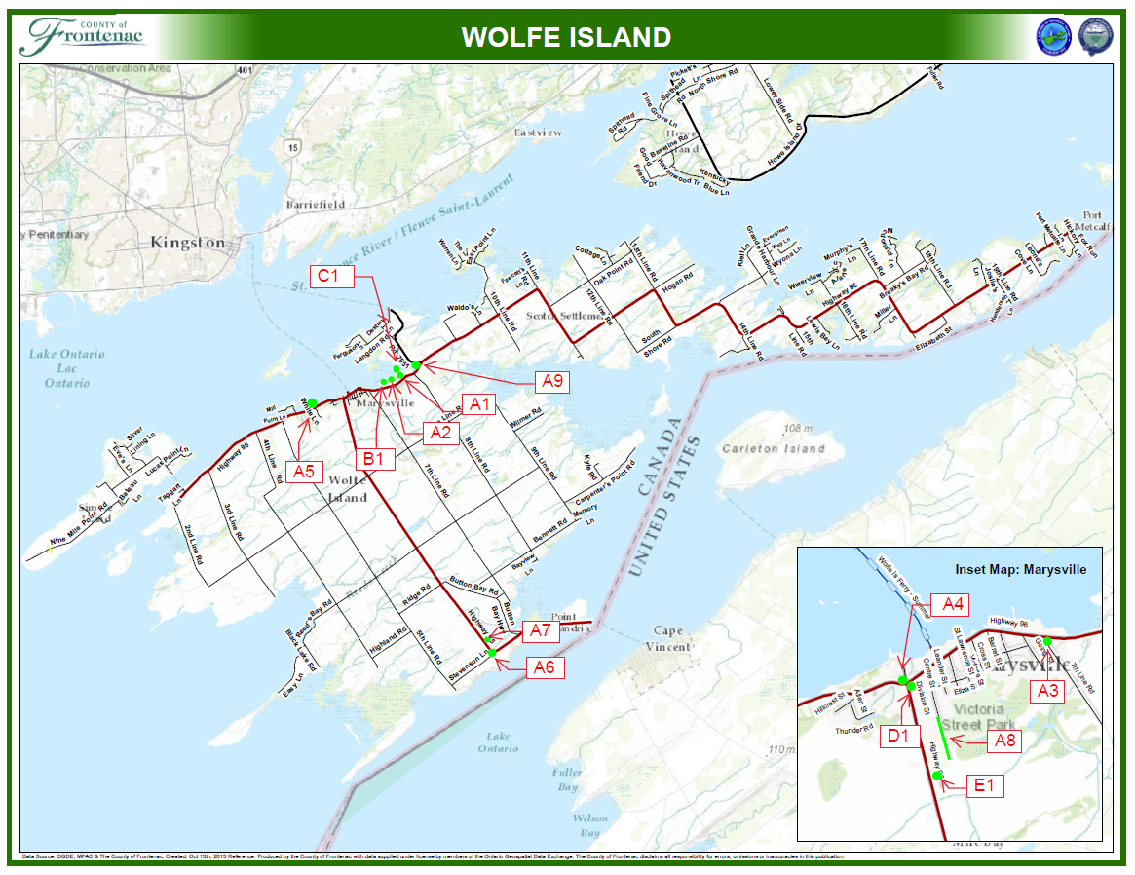

**Wolfe Island Public Works Facilities Grass Cutting Map**